# CS 255 System Design Document Template

## UML Diagrams

### UML Use Case Diagram

### UML Activity Diagrams

### UML Sequence Diagram

### UML Class Diagram

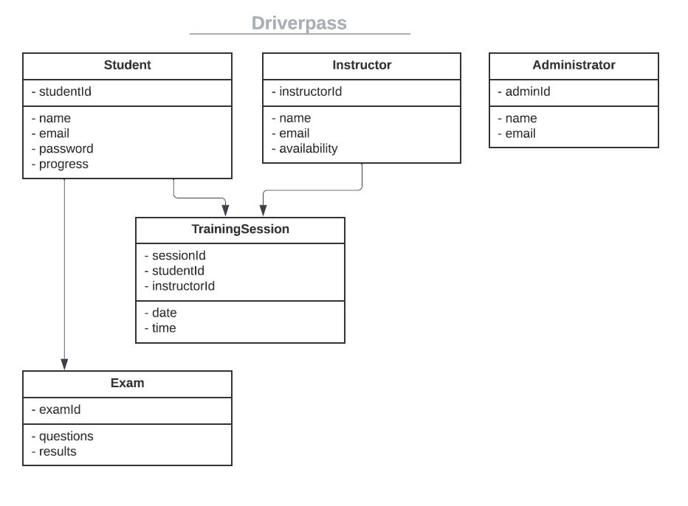

## Technical Requirements

The DriverPass system requires a cloud-based server for scalability, and it must be compatible with major operating systems like Windows, MacOS, Linux, and mobile platforms (iOS, Android). The system should be built using HTML5, CSS3, JavaScript frameworks for the front-end and a Node.js, Python, or Java backend, with a relational database like MySQL or PostgreSQL to store user data, exam results, and schedules.

Security features include SSL/TLS encryption, OAuth/JWT for authentication, firewalls, and intrusion detection systems. Tools such as Lucidchart, Git, and Jenkins will support design, development, and deployment. Cloud-based platforms like AWS or Azure will host the system, ensuring scalability, data backups, and compliance with data protection regulations.